Comparing Universities

**Introduction/Business Problem:**

**Malaysia is one of the top countries that receive big number of new coming students every year from all over the world. By 2019 there were 130,110 international students in Malaysia from 136 countries and Gross Enrolment Ratio in 2016 of 44% is higher than most of the Asian countries, and higher than the world average of 37%.**

**As an international student in Malaysia for 3 years I would try to build a solution for the problem I had and most students are having choosing a university and here is the problem:**

**In the university campus you can find restaurants but they serve only Malay food although some of the university has international food but it is not that quality, so most of students would go outside for eating or order food from outside using grab food app. Same goes for other facilities like barbershops, universities don’t have these ones inside the campus.**

**The solution I would like to build would solve the problem from 2 aspects:**

* **Give the students a clue about the area around the universities so that they can choose the one with more facilities around and easy to be reached or order services from. This would be an area of 5km around the campus, which is a very good area for service delivery, or to go to by yourself, since this will cost like 2.5USD using Grab car or even 20 cents using bus**
* **Give people who are interested in business a good idea about the area around the university, so that they can choose the best business to invest their money in, since there will be so many students coming to these places because it is near to the campus, so a stakeholder may find a business that complete the missing item in the area. Let’s say we have: 2 restaurants, 1 grocery shop, but we don’t have a barbershop in that area, so having one would be a good idea.**

**Data:**

We are going to have 2 datasets merged in one dataset.

We have a Wikipedia page that has 2 tables of public and private universities in Malaysia provided with the: name in English, name in Malay, Acronym, Foundation year, Location, link to the university website.

These 2 tables will be scraped using Pandas in python.

The picture below shows a sample of one of these 2 tables:

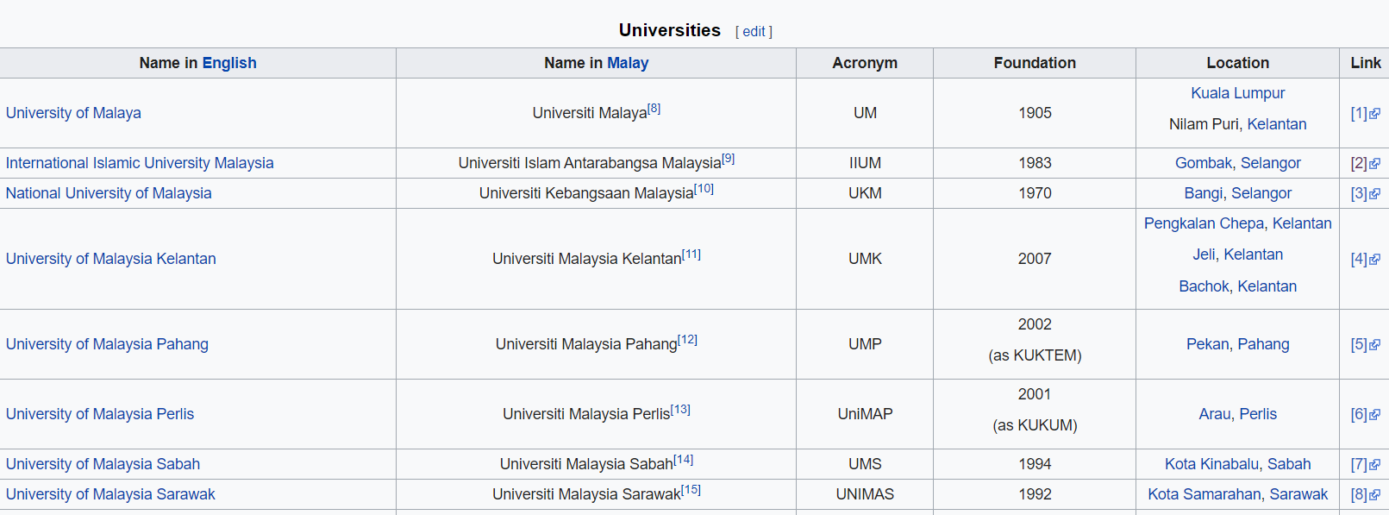

We will also be using Foursquare calls that will return to us a JSON file that we can read it as a panda data frame, in these calls we are going to focus on “explore” call and the category of each venue around the campus in 5km radius